Tube Furnace SOP Liam Cullingford
Research Associate
June 2026

Introduction

The tube furnace is manufactured by Nabertherm (Germany) [R 50/250/12 – R 170/1000/13] and was installed in October 2025. It comprises a central electrically powered furnace surrounding a cylindrical cavity, into which a hollow quartz pipe (length, 1 m, diameter 35 mm) is inserted. The quartz pipe is connected to input gases at the right-hand end, and either to a vacuum pump (when operating at reduced pressure) or left open to air (when operating at 1 atm pressure) on the left-hand side.

Both the Operating Manual for the controller and the Risk Assessment for its use are available on the Intranet section of the diamond group web page.

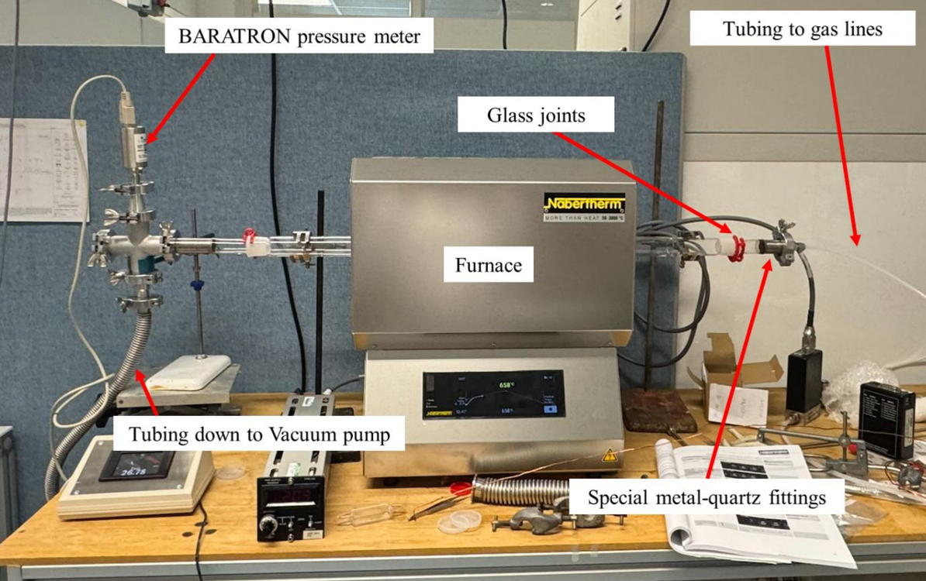

The connections to the large quartz tube are via ground-glass joints and glass-to-metal sealed connectors.
There are several modes of operation:

- No gas, just atmospheric air
In this case, the furnace is just being used as an atmospheric-pressure air oven. Just ensure the RHS is open to air.

- Vacuum anneal.
Ensure no gases are flowing into the furnace, and the RHS is sealed. Pump down to required vacuum level using the LHS pump (see later).
- One or more gases are flowing
Ensure the correct gas(es) is/are connected to the gas input on the quartz tube. If you are using an MFC to control the flow, ensure it is the correct size and type for your gas. Do this for each gas you use. If you are using explosive gases such as H₂, consider diluting it with an inert carrier gas, such as N₂ or Ar. Ensure that the pump is on before flowing these gases otherwise air may backfill the tube causing an explosion.

There are usually shut-off valves either side of the MFCs and one in the mixing manifold before the furnace. Ensure the correct valves are on and/or off when the gases are running. Ensure the MFCs are set to control the correct flow rates. If a needle valve is used instead of an MFC, adjust it to the flow required by opening it slowly and listening for the hiss.

- Using a liquid bubbler
Fill the bubbler with the correct liquid (e.g. deionised water) and attach it to the gas input system in such a way that the carrier gas can pass either through the bubbler (pathway A) or bypass it (Pathway B), (see diagram).

First, pass the carrier gas (usually N₂) through pathway B (open valves 1, 2, 3 and 4, shut valves 5 & 6), then through pathway A (open valves 1, 4, 5 and 6, shut valves 2 & ), to replace all the air in the system with carrier gas. When using pathway A, valve 1 (or an MFC) can be used to control the flow; watch the bubble in the flask to ensure the flow is not too energetic. If the system is being run in open mode (i.e. with the LHS of the quartz tube open to air), you should be able to feel a small flow of gas exiting the furnace. This flow needs to be sufficient to prevent back-flow of air into the furnace, but not so great the bubbler is splashing too violently.

To begin a run, insert the sample into the furnace (see above), then flush through with the carrier gas (Pathway B) while the furnace heats up to its set-point. This might take anywhere from a few mins to a couple of hours, depending on the set temperature. When at the set-point, switch the valves to pathway A through the bubbler, and adjust flow as needed.

After run is finished, either cool down the furnace with the bubbler still running (Pathway A), or switch to the carrier gas only (Pathway B). When cool enough, remove sample from furnace (optionally with gas still flowing if surface is air sensitive).
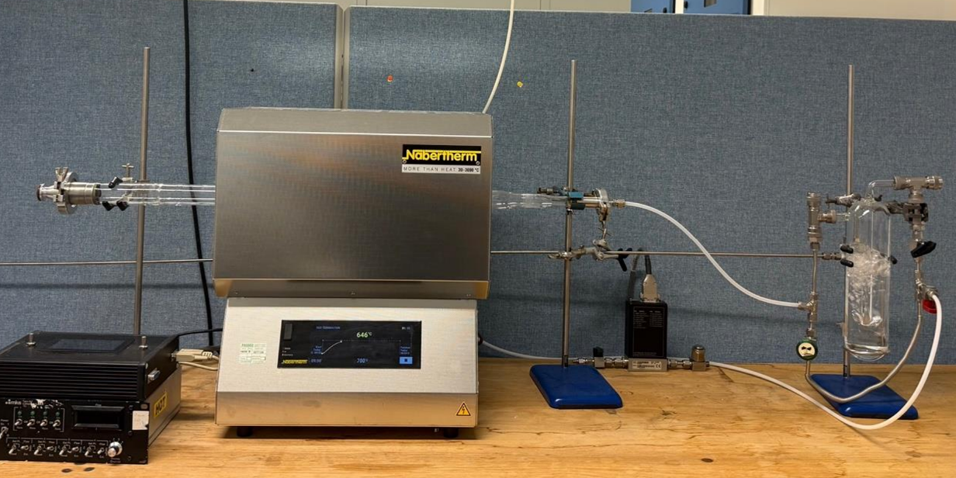

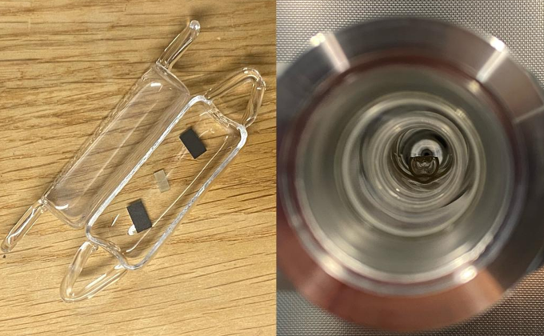
Inserting the substrate
Substrates are placed into a quartz boat and loaded into the quartz tube by breaking the seal at the ground-glass joint on the LHS. Ensure the quartz tube is not under vacuum before breaking this seal. A long steel rod with a hook at one end is then used to push/slide the boat along the bottom of the tube until it sits in the centre of the furnace. It is best to measure this distance on the outside of the furnace and put a mark on the rod so you know how deep to push, before inserting the sample. Insert sample slowly and carefully so that vibrations or wobbles don’t cause the substrate to jump out of the boat. Unattach the hook, and retract the rod.

Removing the substrate
When the tube furnace is cold, and is no longer inder reduced pressure, break the LHS seal, and use the long rod to hook the ‘eye’ of the quartz holder. Gently drag the holder to the end and remove it – Carful, it may still be hot.
The gas input system

Before beginning your experiment, ENSURE THE CORRECT GASES ARE CONNECTED TO THE EXPECTED GAS LINES - they should be labelled but it is your responsibility to check.

Using the pump for low pressure runs

Loading & Unloading samples:
- Ensure furnace is cold. If you vent to (cold) air when the centre of the furnace is still very hot (> 400 °C), the thermal shock may shatter the quartz tube.
- Ensure pump valve is shut and the furnace is isolated.
- Vent chamber to air. The easiest way is to slowly open vent tap opposite the MFCs.
- Check pressure has equalised with lab using pressure gauge
  - Atmospheric pressure = 1 bar / 760 Torr
- Detach the flexible metal pipe from the furnace at the KF fitting on the LHS.
- Insert sample (see above)
- Reattach flexible metal pipe at KF fitting.

Low pressure run:
- Ensure all valves and taps are closed.
- Open only those taps which need opening to pump the system down. Lastly, open the pump valve to begin evacuation.
- Wait until pressure reaches ~1×10⁻² mbar.
- Ensure proportional valve controller is switched on and is completely open (~72%).
- ENSURE THE CORRECT GASES ARE CONNECTED TO THE EXPECTED GAS LINES - they should be labelled but it is your responsibility to check.
- Set MFCs using MKS controllers.
- Open valves before and after MFC. Check gas is flowing correctly.
- Adjust the pressure using the proportional valve to produce a steady state.
  - NB: the percentage value refers to how "open" the valve is so to increase the pressure, reduce this percentage to close the valve - BE CAREFUL TO NOT OVERPRESSURE (ENSURE THERE IS ALWAYS SOME GAS BEING PUMPED IF IT IS A CLOSED SYSTEM)
- Program tube furnace (see manual) and begin run. WHILE THE TUBE FURNACE IS IN OPERATION SOMEONE SHOULD ALWAYS BE SAT WITH IT - especially in the case of reduced pressure procedures.
- When program ends, stay with it until temperature < 300°C and leave FULLY OPEN (~72%) valve (or end of tube disconnected from pump) before leaving it unattended.
- When cool, remove sample (see above).

Turning off furnace and leaving for a long time:
If the furnace is not going to be used for several days or longer, then shut it down. The tube furnace should be left at atmospheric pressure with the KF tube detached. No samples should be left inside and the pump, furnace and control boxes should be switched off at the plugs.

